WEEK 4 DAY 2 TASK 3
POWER BI
1.DOWNLOAD POWER BI DESKTOP
2. has three data sets
Customer
Products
Sales
3. imported customer datasets in power bi
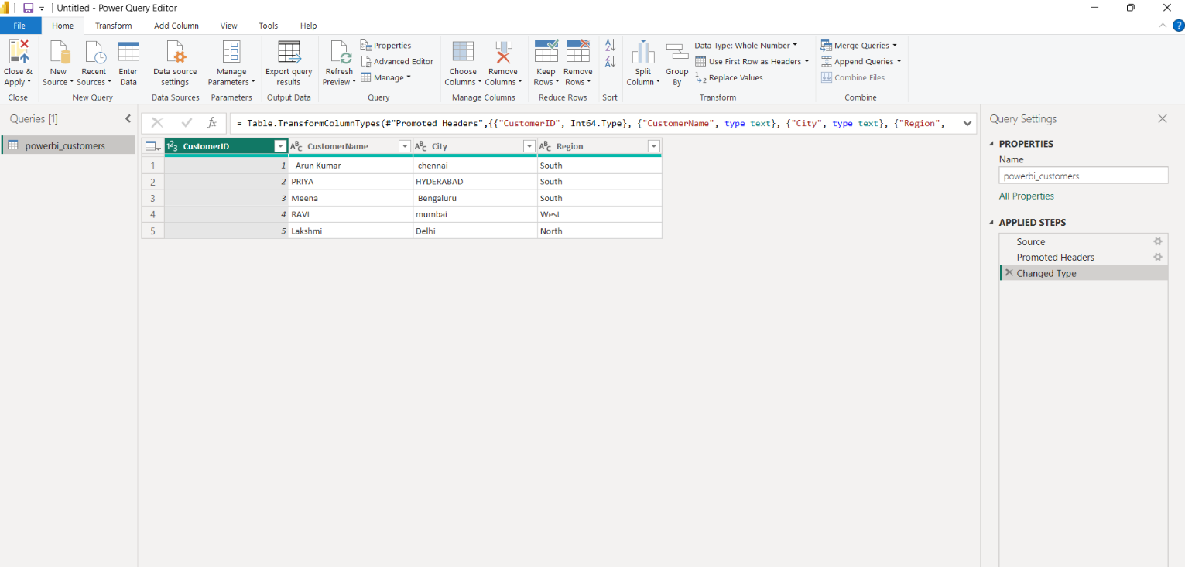
Imported customer and sales
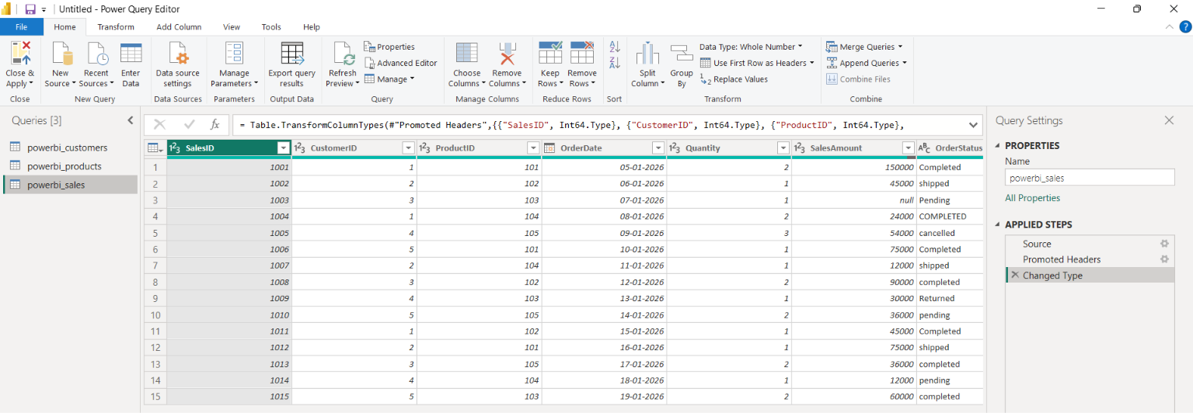

Now to clean the customer table
- Remove extra spaces
Using trim in format
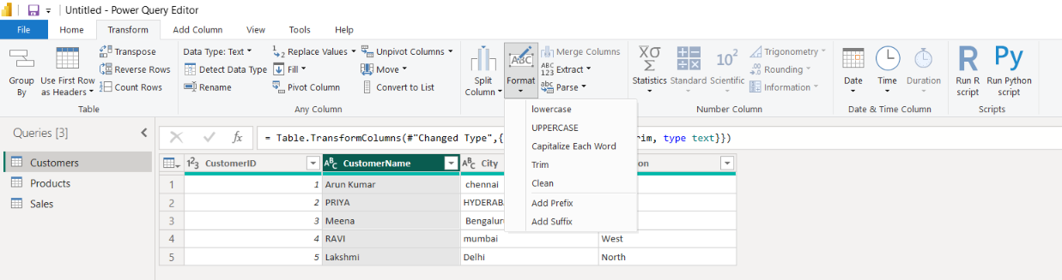

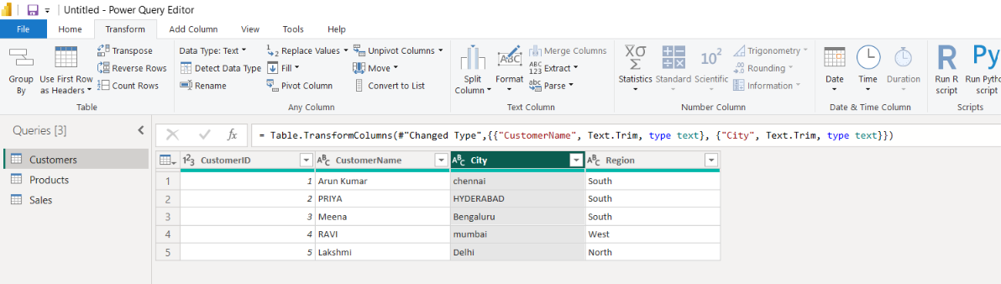
Both the customer name and city are trimed

- Text
Changing customer name , city and region to uppercase
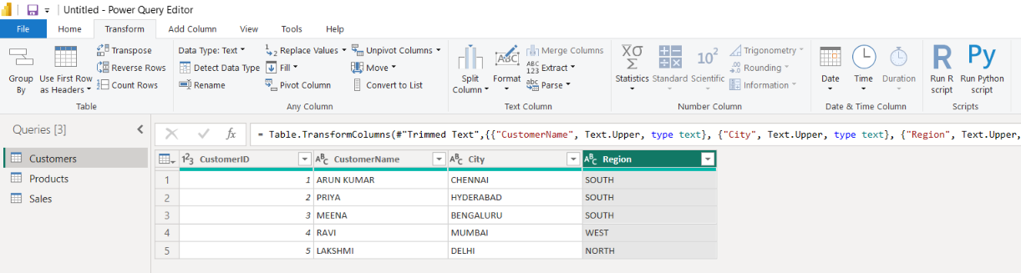

- Checking the data types
  - Customer if : whole no
  - Customer name , city and region : text

Cleaning the products table
Before
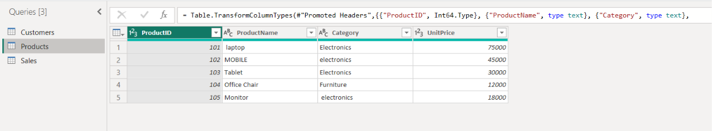

- For product name and category applying trim and upper
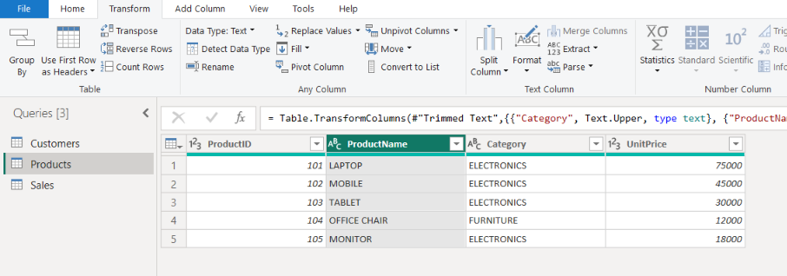
- Changing the unit price data type to decimal
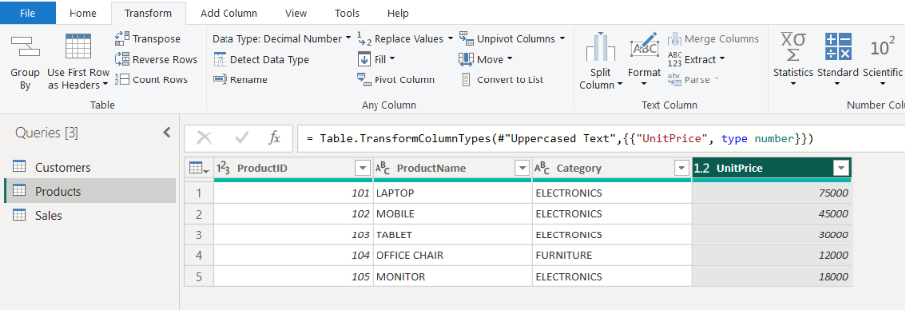

Cleaning the sales table
Before
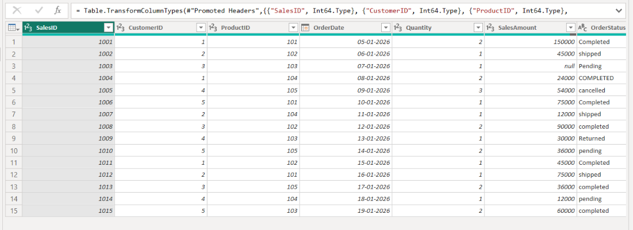

- Cleaning the order status in sales by using trim and uppercase
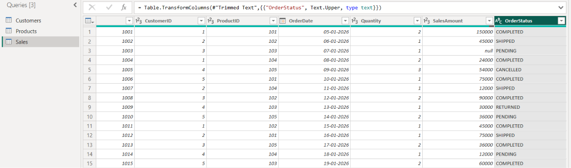
- Changing the sales amount data type to decimal
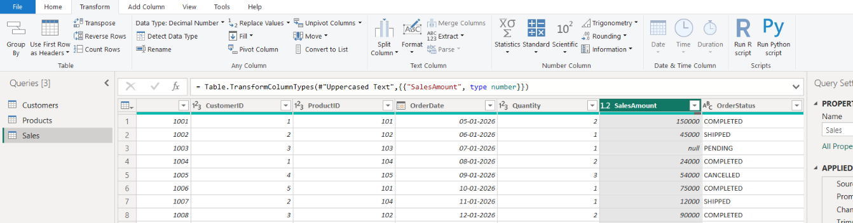

Now all the transformations and cleaning done
Close and apply
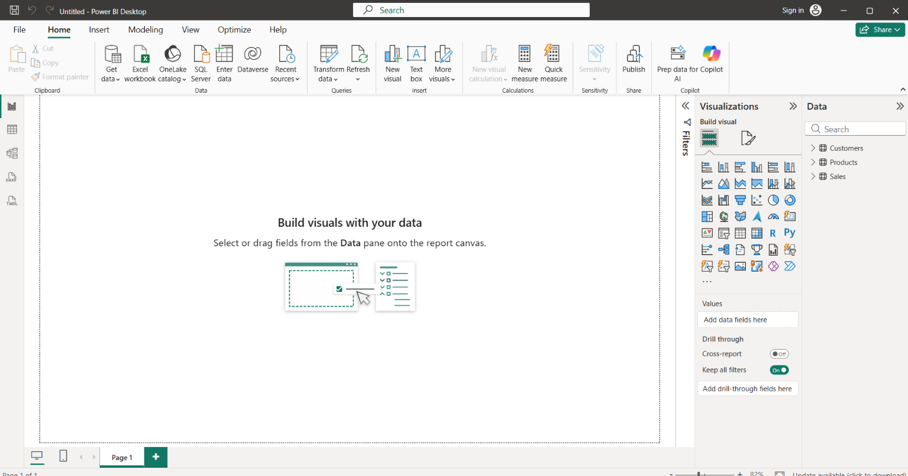
Model view of the table
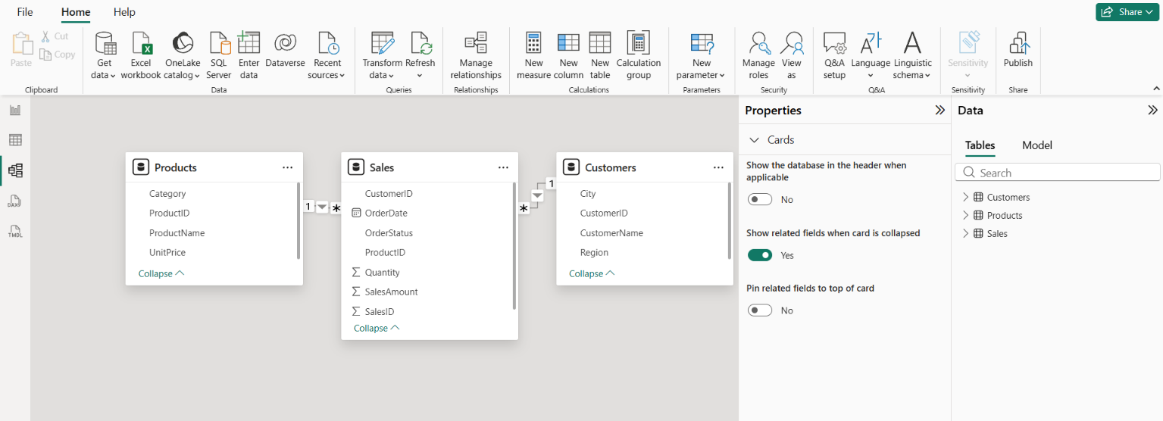

Now creating relationships
Customers to sales relationship
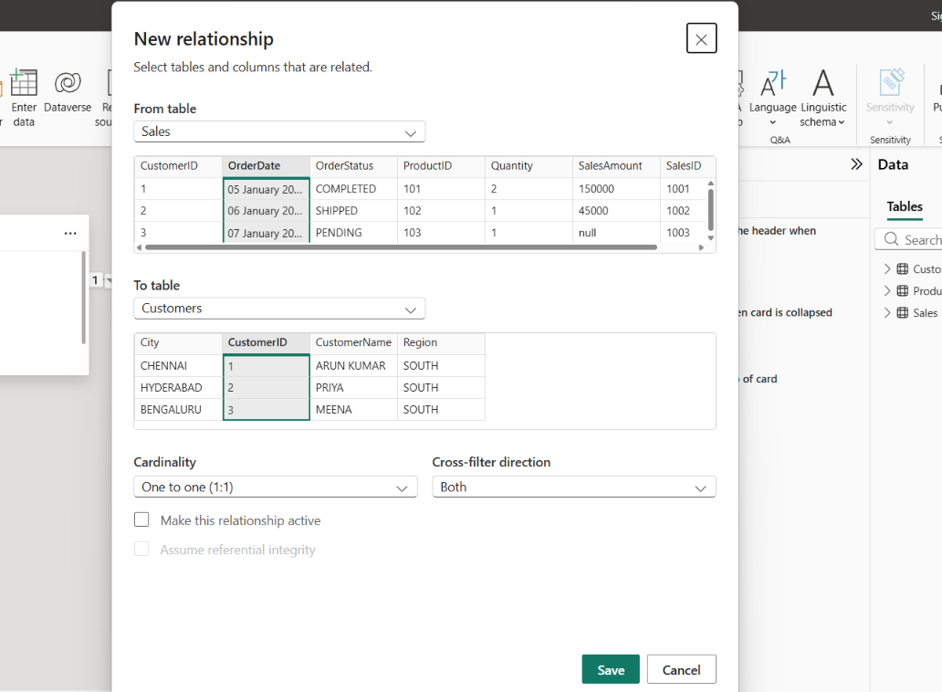
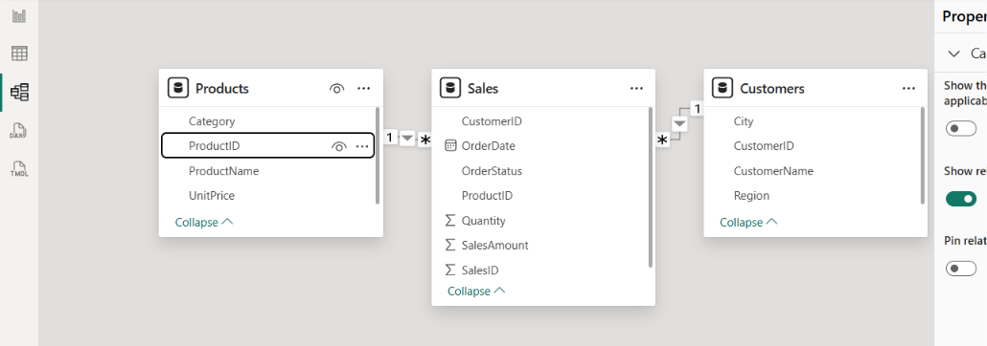

Creating calculated table
Created a sales tabe
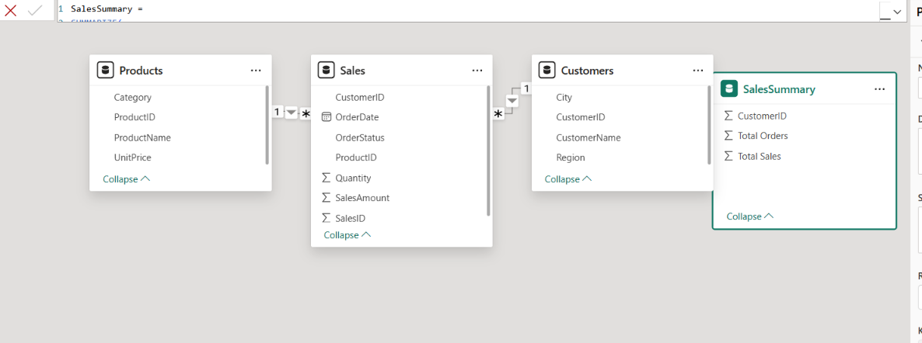

Created sales summary table and completed table
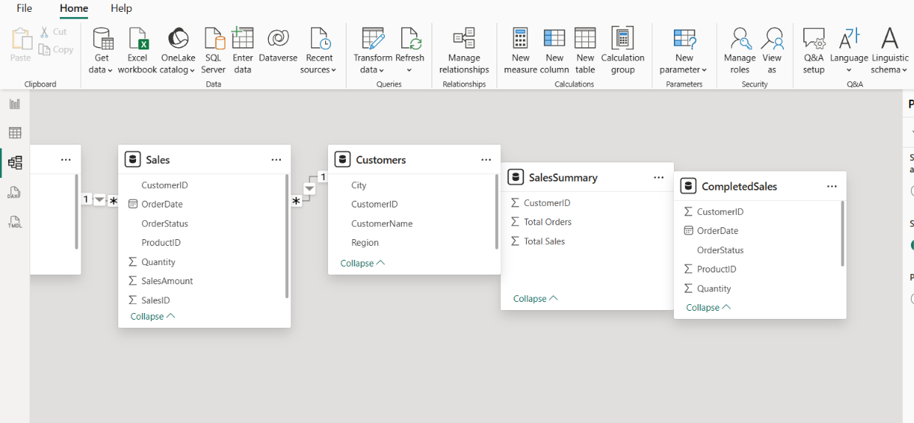

Creating total revenue
Total sales card
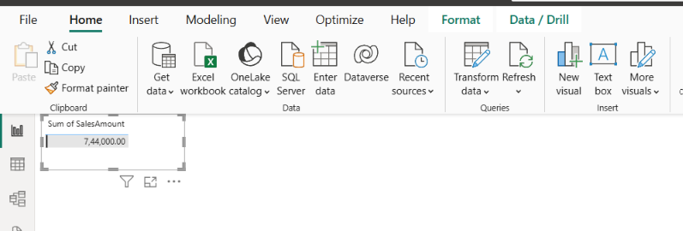

Sum of sales amount by region
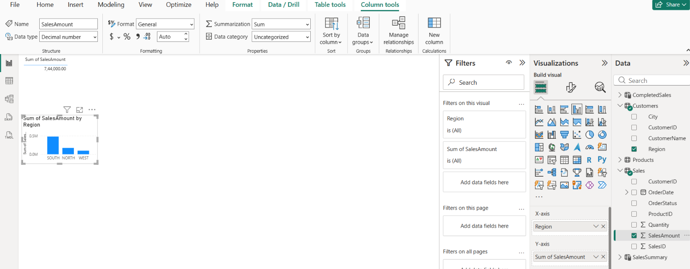

Product category slicer
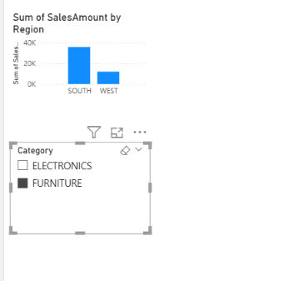
Creating sales detail table


